HOME COOK Web App

## Introduction

This app is come from my initiative on helping Housewife selling their products.

Home Cook website was built with such technologies:

* ASP.NET Core MVC, EF Code First, LINQ, Dragger.
* MS. SQL
* Image uploading: <https://pqina.nl/filepond/docs/patterns/api/filepond-instance/#events>
* Datatable.net

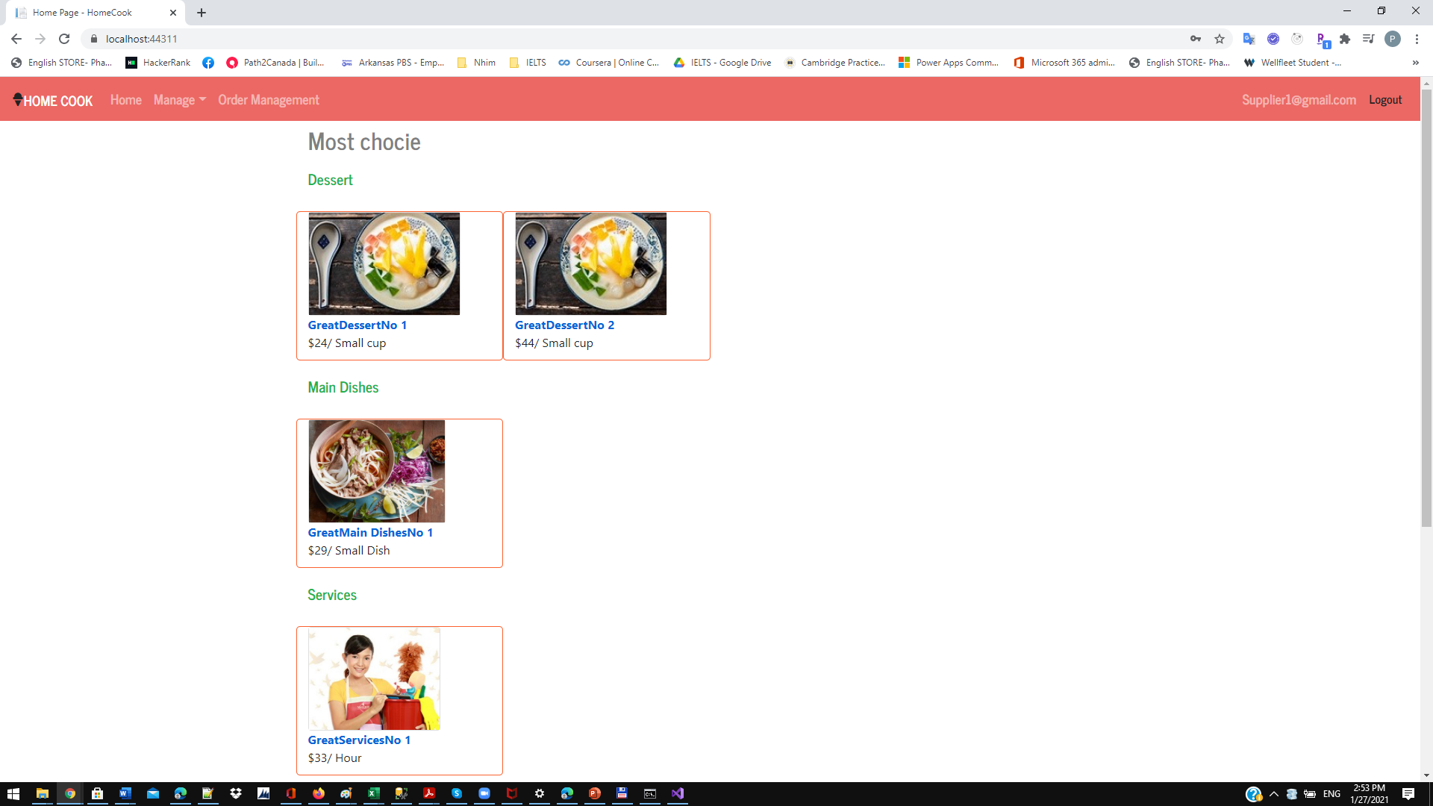

## Functions

Currently the web app have some functions as :

|  |  |  |  |
| --- | --- | --- | --- |
| Functions | Admin | Supplier | Customer |
| Create/ Update/Delete Category , Unit | X |  |  |
| Create/Update Product |  | X |  |
| Activate/Inactivate product | X |  |  |
| Update Price |  | X |  |
| View Product | X | X | X |

## Solution

|  |  |
| --- | --- |
|  | Solution has 4 projects :  + HC.Data Access : provide methods for access data  + HC.Model : has 2 types  Model classes provide the data structure  ModelView classes are the data structure that is used in Views  + HC.Ultitly : includes common functions  + HomeCook : contain the controllers & views of the HomeCook website. |

## Database Design



## Design Pattern

* MVC
* Repository Pattern to provide the abstraction of data and remove redundant code.

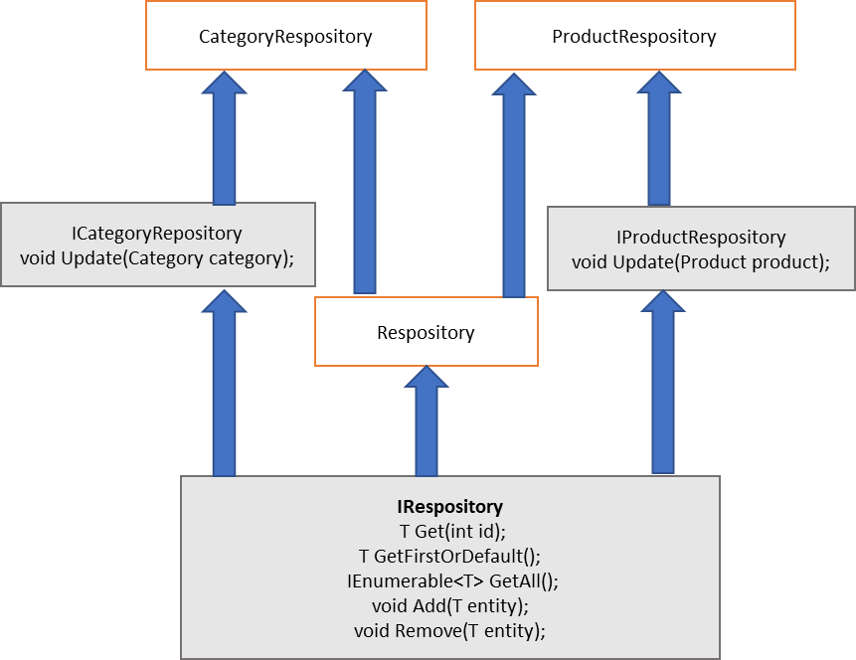

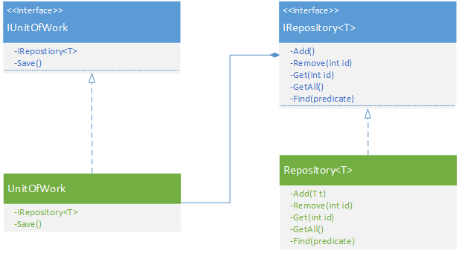

## Testing

Download the source code <https://github.com/phanthao83/HomeCook2>

Change the DefaultConnection string in appsetting.json to your database

Press F5 to run the app. Please note that when the app is started, database and test data will be created.

Account for Admin Role : [Admin1@gmail.com](mailto:Admin1@gmail.com) / P@ssword123

Account for Supplier Role : [Supplier1@gmail.com/P@ssword123](mailto:Supplier1@gmail.com/P@ssword123)

Account for Customer : Customer1@gmail.com/P@ssword123

## WebAPI Sample

